Screen -1:
Login/sign up
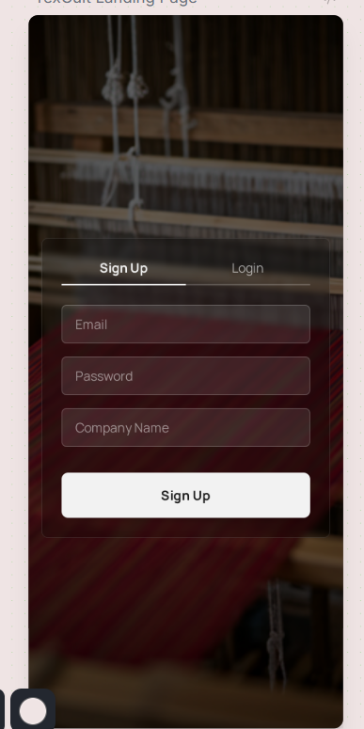

Screen-2:
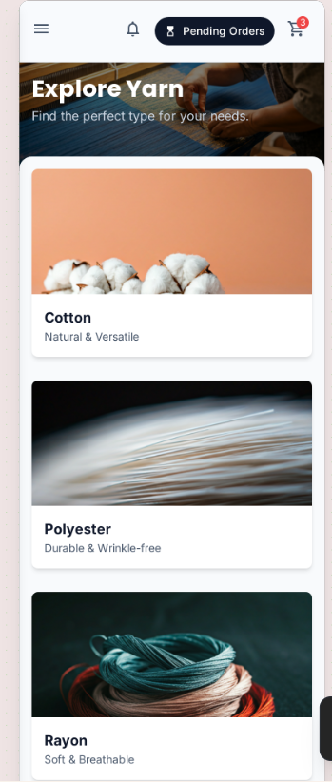
Function | Description
Profile | Goes to the profile page
Orders | Goes to the orders page
Log out | Logs out the user
Explore products | Displays the product category
notification | Goes to the notification
cart | Goes to cart
Pending orders | Pop up of the pending orders when the user comes to this page

Screen-3:
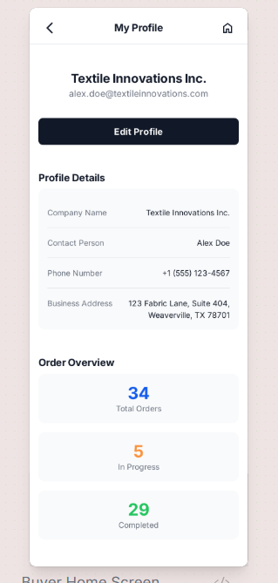
Function | Description
Opening screen-display the profile
edit | Option to edit the profile
Home | Goes to the home screen

Screen-4:
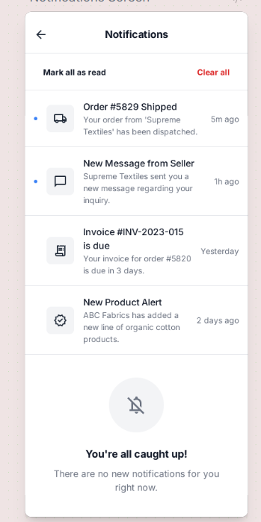
Function | Description
Opening page | Display the notification
Clear all | Deletes the notification in the screen and in the db

